**Callus induction and plant regeneration in *Lychnis wilfordii* (Regel)Maxim, an critically endangered plant in Korea**

**Kee Hwa Bae1, Mi Hyun Lee, Yong Eui Choi3, Eui Soo Yoon4\***

1National Institute of Biological Resources, 42 Hwangyeong-ro, Seo-gu, Incheon, 404-708, Republic of Korea

2R&D center, Asiaseed Co. Ltd., Icheon, 447-2, Gyeonggi Province, Republic of Korea

3Division of Forest Resources, College of Forest and Environmental Sciences, Kangwon National University, Chunchon, Kangwon-do 200-701, Republic of Korea

4Department of Biology, College of Nature Sciences, Kongju National University, Kongju 314-701, Republic of Korea

**\*** For correspondence

Eui-Soo Yoon

Department of Biology, College of Nature Sciences, Kongju National University, Kongju 314-701, Republic of Korea

Tel: 82-41-850-8502

Fax: 82-41-850-8510

E-mail: [yes@kongju.ac.kr](mailto:yes@kongju.ac.kr)

No. of Table: 2

No. of Figure: 2

**Callus induction and plant regeneration in *Lychnis wilfordii* (Regel)Maxim, an critically endangered plant in Korea**

**Kee Hwa Bae1, Mi Hyun Lee, Yong Eui Choi3, Eui Soo Yoon4\***

1National Institute of Biological Resources, 42 Hwangyeong-ro, Seo-gu, Incheon, 404-708, Republic of Korea

2R&D center, Asiaseed Co. Ltd., Icheon, 447-2, Gyeonggi Province, Republic of Korea

3Division of Forest Resources, College of Forest and Environmental Sciences, Kangwon National University, Chunchon, Kangwon-do 200-701, Republic of Korea

4Department of Biology, College of Nature Sciences, Kongju National University, Kongju 314-701, Republic of Korea

**Abstract**

*Lychnis wilfordii* (Regel) Maxim is a rare and valued ornamental plant. Since seed propagation has not been regarded as a proper method for *in vitro* germination and propagation of this species. Germination rate reached 46.6% when seeds were treated with 1,443 μM GA3. The highest callus induction was observed in the leaf explants of the seedlings on MS medium containing specific concentrations of 2.22 μM BA and 16.11 μM NAA. The adventitious shoot was formed 97.3% of calli on 1/2 WPM medium. The plantlets grew well after transferring to the pot. The height of *in vitro* propagated plantlets was no difference among regenerated medium. This *in vitro* propagation protocol should be useful for conservation of this endangered plant.

**Key words:** callus, endangered plant, *In vitro* germination, *L*. *wilfordii*

**Introduction**

The genus *Lychnis* belongs to the family Caryophyllaceae and consists of about 30 species in the world. *Lychnis* spp. are distributed throughout the temperate regions of the Northern Hemisphere, from East Asia to Europe (Magnus et al. 2008), and 4 *Lychnis* spp. are native to Korea (Lee 1974). Some species of *Lychnis* spp. are frequently grown in Korea for horticultural use.

*Lychnis wilfordii* (Regel) Maxim is a perennial and narrowly distributed in Kangwon province of Korea. Also, it is rare and critically endangered species which is subjected to strict protection as an endemic plant. The population size declines rapidly. For this reason, the Ministry of Environment (MEV) has designated the species as ‘Threatened to extinct : the second grade (2) for preservation’ (Lee and Choi 2006). Also, this species reproduction by seeds is rarely used due to poor seed germination and low seed production.

Therefore, the development of an *in vitro* protocol will be of great importance for conservation and sustainable utilization of this species. However, propagation protocols for this species *in vitro* have not yet been reported.

In the present study, for the first time, we report the establishment of a high frequency plant regeneration system *via* organogenesis in *L. wilfordii*.

**Materials and Methods**

Seeds of *L. wilfordii* were collected from a wild population of Mt. Odae National Park in Korea late September of 2010. Mature seeds of *L. wilfordii* were scarified by immersion in 70% EtOH for 1 min and then sterilized with sodium hyporchloride (NaOCl) 1% (v/v) (5% of sodium hypochlorite, Sigma, USA) with a few drops of Tween-20 (Sigma, USA) for 30 min. For the GA3 treatment, seeds were soaked in 1,443 μM GA3 solution for 24h before incubation. The seeds were washed 5 times in sterile water and placed into petri-dishes containing hormone-free MS (Murashige and Skoog 1962) medium under white fluorescent lights (30 μmol m-2 s-1) on a 16 h photoperiod or in the dark at 25℃. The germination rate was tested after 8 weeks of culture. Thirty seeds were incubated for each treatment and repeated five times, and the seeding used in subsequent experiments.

After cutting the leaf, stem and root explants into 10 mm in sizes, they were cultured on MS medium supplemented with auxin (0, 5.37 and 16.11 μM NAA : a-naphthaleneacetic acid, 0, 5.71 and 17.13 μM IAA : indoleacetic acid ) and/or cytokinin (0, 2.22 μM BA : N6-benzyladenine). All media were supplemented with 30 g/l sucrose and solidified with 8.0 g/l plant agar, and then adjusted to 5.8 pH before autoclaving at 121℃ for 20 min. Calli were maintained under cool white fluorescent lights (30 μmol m-2 s-1) on a 16 h photoperiod at 25℃. The frequency of callus induction was evaluated after 12 weeks of culture. Thirty explants (leaf, stem and root) were incubated for each treatment and repeated five times.

Calli were transferred to WPM (Lloyd and McCown 1980), half-strength WPM, one-third strength WPM medium and MS, half-strength MS, and one-third strength MS medium for the growth of plantlets. The culture room was maintained at 25℃ with a 16 h photoperiod under 30 μmol m-2 s-1 white fluorescent light. Adventitious shoot formation rate was evaluated by counting plantlets with well-developed shoot primordia after 4 weeks of culture. And, plants with better roots were transplanted into a mixture composed of vermiculite and pealrite (1:1) in the single pot. Plantlet height was evaluated by measuring average length of shoots and roots after 4 weeks of culture.

All data were analyzed using ANOVA and expressed as means ± standard error (SE). To examine significant differences among the treatments, multiple comparison tests were then performed by Duncan’s multiple range test at p ≤ 0.05 (SAS 2001).

**Results and Discussion**

The germination rate of seeds was increased with GA3 treatment as shown in Fig. 1. The germination rate reached 46.6% when seeds were treated with 1,443 μM GA3. However, the germination rate was still not sufficient for production of the species by seed propagation. Therefore, *in vitro* propagation of *L*. *wilfordii* was performed in the subsequent experiments. Callus formation varied significantly depending on kind of explants and plant growth regular (PGR) of *L*. *wilfordii* (Table 1). When explants were cultured on medium with BA, callus formation was more efficient compared to the explants without BA treatment. And the frequency of callus formation was higher on medium with NAA than on IAA (Table1). Leaf explants formed callus after 8 weeks of culture, but stem and root generated callus from cut surfaces after 10 weeks of culture. Calli of leaf (Fig. 2B) and root (Fig. 2C) were compact, globular and yellowish on MS medium with both 2.22 μM BA and 16.11 μM NAA after 12 weeks of culture, but control (non-treated PGR) did not form callus (Table 1). The frequency of callus formation leaf explants showed that the highest frequency (86.6%) of callus formation was obtained when the medium was supplemented with both 2.22 μM BA and 16.11 μM NAA after 12 weeks of culture. However, stem and root explants exhibited 73.3% and 12.7% callus formation, respectively (Table 1). To determine adventitious shoot induction from callus, both types of callus (compact and friable ones) were transferred onto media (WPM, 1/2WPM, 1/3WPM, MS, 1/2MS, and 1/3MS). After 20 to 25 days of culture, calli turned greenish (Fig. 2D) and several adventitious shoot regenerated on 1/2MS medium (Fig. 2E). The highest adventitious shoot induction rate was obtained in 1/2WPM medium (99.3%) (Table 2). However, there was not a remarkable difference on the growth of plantlets among the six media. The height of *in vitro* propagated plants in pot was around 20∼35cm (Fig. 2F).

Based on our preliminary study, *L*. *wilfordii* seeds have a poor and unpredictable germination rate. The result suggested that *L*. *wilfordii* seeds have deep dormancy. It has been reported that approaches to break seed dormancy such as hormonal, temperature, etc. are necessary (Seiler 1998, Mabberley 1989). Endogenous GA3 has been widely studied in relation to the breakage of seed dormancy in various plant species. GA3 treatment was resulted in improve germination of many plant species (Nicolas et al. 1996, Rehman and Park 2000). In the present study, it was found that the germination rate was increased in of GA3 treated seeds comparison to the control treatments. *In vitro* culture technique is an alternative ways for germplasm conservation and micropropagation of valuable endangered plants. It has the advantages of preserving healthy plant material in a small space, easy and rapid multiplication for international exchange as well as cost reduction. Generally, addition of BA to the medium could induce the formation of adventitious buds. In the present study, the multiplication coefficient rose with the treatment of BA and NAA, respectively, but there was no interactive effects of BA and NAA. However, in the present study, we established the tissue culture system to propagate the *L*. *wilfordii* and this technique may be applicable to commercially propagated the endangered *L*. *wilfordii* speices.

**Acknowledgements:** This work was supported by the research grant of the Kongju National University in 2012

**References**

Lee Y.N. (1974) New taxa on Korean flora (1). Korea Journal of Botany, 17: 33-35.

Lee J.S., Choi B.H. (2006) Distribution and red data of wild orchids in the Korean Peninsula. Korea Jounal of Plant Taxon, 36: 335-360.

Lloyd E., McCown, B. (1980) Commercially feasible micropropagation of mountain laurel (*Kalmia latifolia*) by use of shoot tip culture. Comb. Proc. Int. Plant Prop. Soc, 30: 421-427.

Magnus P., Abel G., Sileshi N., Jan S., Christian B. (2008) Colonization and diversification in the African ‘sky islands’ by Eurasian *Lychnis* L. (Caryophyllaceae). Journal of Biogeography, 35: 1016-1029.

Mabberley D.J. (1989).The plant-book: a portable dictionary of the higher plants. Cambridge: Cambridge University Press.

Murashige T., Skoog F. (1962) A revised medium for rapid growth and bioassays with tobacco tissue culture. Physiol. Plant, 15: 473-497.

Nicolas C., Nicolas G., Rodriguez D. (1996) Antagonistic effects on abscisic acid and gibberellic acid on the breaking of dormancy of *Fagus sylvatica* seeds. Physiol. Plant, 96: 244-250.

Rehman S., Park I.H. (2000) Effect of scarification, GA and chilling on the germination of golden rain-tree (*Koelreuteria paniculata* Laxm.) seeds. Sci. Hort, 85: 319-324.

SAS. (2001) SAS/STAT User’s guide (8.02) SAS Institute Inc., Cary, NC, USA.

Seiler G.J. (1998) Seed maturity, storage time and temperature, and media treatment effects on germination of two wild sunflowers. Agron. Journal, 90: 221- 226.

Table 1. Effect of NAA and IAA in combination with BA on callus formation from leaf, stem and leaf explants of *L*. *wilfordii*. MS medium containing 30 g/L sucrose. Data were collected after 12 weeks of culture. Data are the means ± SD, of five time experiments, n=30. Different alphabetical letters are significantly different according to Duncun's multiple range test at P≤ 0.05.

|  |  |  |  |  |  |  |
| --- | --- | --- | --- | --- | --- | --- |
| PGR’s (μM) | | |  | Callus formation (%) | | |
| BA | NAA | IAA |  | Leaf | Stem | Root |
| 0 | 0 | 0 |  | 0 | 0 | 0 |
| 5.37 | 0 |  | 33.3±5.3 e | 22.7±4.3 e | 8.7±3.8 ab |
| 16.11 | 0 |  | 34.7±5.1 e | 30.0±5.3 d | 9.3±2.8 a |
| 0 | 0 |  | 0 | 0 | 0 |
| 0 | 5.71 |  | 30.0±5.3 e | 26.7±5.3 d | 11.3±3.8 a |
| 0 | 17.13 |  | 33.3±6.2 e | 28.7±3.8 d | 13.3±5.3 a |
| 2.22 | 0 | 0 |  | 0 | 0 | 0 |
| 5.37 | 0 |  | 80.7±9.5 b | 71.3±8.7 a | 11.3±3.8 a |
| 16.11 | 0 |  | 86.6±4.3a | 73.3±11.8 a | 12.7±4.9 a |
| 0 | 0 |  | 0 | 0 | 0 |
| 0 | 5.71 |  | 52.0±9.6 d | 48.0±3.8 c | 13.3±4.7 a |
| 0 | 17.13 |  | 67.3±5.5 c | 64.7±5.6 ab | 14.0±4.9 a |

Table 2. Effect of various kinds of medium on adventitious shoot formation and Plantlet conversion of *L. wilfordii* from callus. Adventitious shoot formation (%) was collected after 8 weeks of culture. Plantlet conversion was collected after 12 weeks of culture. Data are the means ± SD, of five time experiments, n=30. Different alphabetical letters are significantly different according to Duncun's multiple range test at P≤ 0.05.

|  |  |  |  |
| --- | --- | --- | --- |
| Media | Adventitious shoot formation (%) | Plantlet conversion | |
| Length of shoot (cm) | Length of root (cm) |
| WPM | 82.0±6.5cd | 12.0±1.6a | 3.0±0.7b |
| 1/2WPM | 99.3±1.5a | 13.0±1.0 a | 2.8±0.8c |
| 1/3WPM | 96.7±4.7ab | 12.6±1.5 a | 2.8±0.8c |
| MS | 86.7±5.3c | 13.0±1.0 a | 3.4±1.1a |
| 1/2MS | 97.3±4.3ab | 12.4±1.1 a | 3.0±0.7b |
| 1/3MS | 97.3±4.3ab | 12.0±1.0 a | 3.4±0.9a |

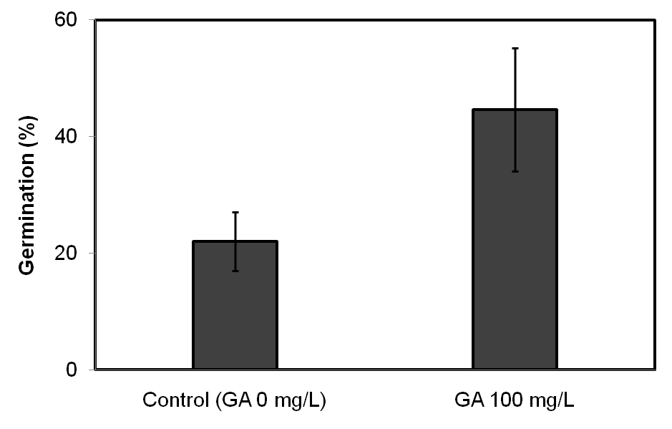

**Fig. 1.** Effect of GA3 on germination of *L*. *wilfordii*: Thirty seeds were incubated for each treatment with five replicates. Germination rate (%) was recorded after 4 weeks of culture.

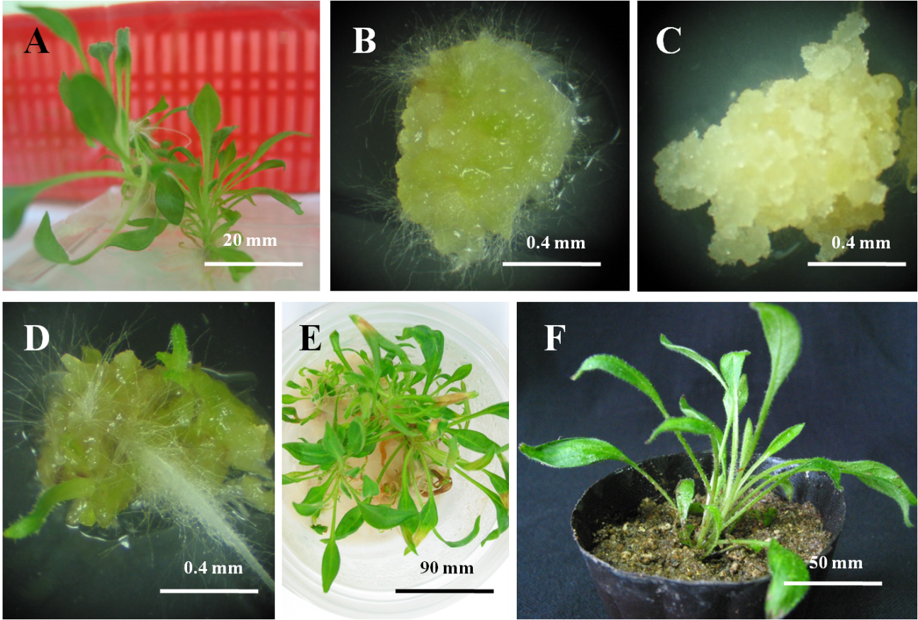

**Fig. 2.** Plant regeneration from callus derived from *L. wilfordii*. *In vitro* seedling of *L*. *wilfordii* (A). Initiation of callus induction from leaf explants on MS medium with 0.5 mg/l BA and 3.0 mg/l NAA0.4 mm) (B). Initiation of callus induction from root explants on MS medium with 0.5 mg/l BA and 3.0 mg/l NAA (scale bar indicates 0.4 mm) (C). Conversion of shoot and root on 1/2MS medium without PGR’s after 4 weeks of culture (scale bar indicates 0.4 mm) (D). Proliferation of shoots on 1/2MS medium without PGR’s after 8 weeks of culture (scale bar indicates 90 mm) (E). Plantlet in sterile soil, vermiculite and pealrite (1:1) mixure for 10 day (scale bar indicates 50 mm) (F).